LEVEL UP – Redesign

The domain of the Project:

G5 - UIUX

Team Mentors (and their designation):

Sir Sen Ghiri Sudhan

UI/UX Designer - MetricStream

Team Members:
Ms. Trupti Zaware

Period of the project

July 2025 to December 2025

Declaration
The project titled “Level Up –Redesign” has been mentored by Sir Sen Ghiri Sudhan, organised by SURE Trust, from July 2025 to December 2025, for the benefit of the educated unemployed rural youth for gaining hands-on experience in working on industry relevant projects that would take them closer to the prospective employer. I declare that to the best of my knowledge the members of the team mentioned below, have worked on it successfully and enhanced their practical knowledge in the domain.

Team Members:
Ms. Trupti Zaware
Signature

Mentor’s Name – Sir Sen Ghiri Sudhan
Designation- UI/UX Designer - MetricStream

Prof. Radhakumari
Executive Director & Founder
SURE Trust

Table of contents
- Executive summary
- Introduction
- Project Objectives
- Methodology & Results(Screenshots)
- Learning & Reflection
- Future Scope & Conclusion

Executive Summary
- This project focuses on redesigning the LevelUp app to improve usability, visual clarity, and user experience.
- The redesign was based on a given assignment and aimed to enhance both UX flow and UI aesthetics.
- The project involved identifying design gaps and refining the overall experience.

Introduction
- Although the initial LevelUp design addressed productivity and motivation, certain usability and visual issues were identified.
- The redesign project aimed to improve navigation, reduce cognitive load, and enhance visual hierarchy.
- The scope included UX improvements and UI refinement without changing the core concept.

Project Objectives
- Improve task flow clarity
- Enhance visual hierarchy and readability
- Refine gamification elements
- Improve overall user experience

Methodology and Results
Methodology Used:
- UX audit of existing design
- Identification of pain points
- Flow restructuring
- UI refinement
Tools Used:
- Figma
- FigJam
- Notion
Results:
The redesigned version offers a cleaner interface, smoother navigation, and better engagement.

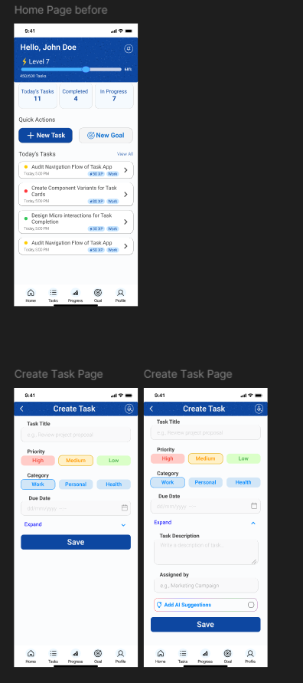
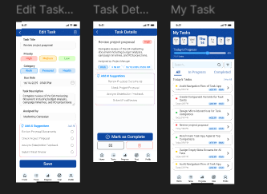

Learning and Reflection
This project helped me understand the importance of iteration and UX refinement based on real constraints.

Conclusion and Future Scope
Further usability testing and data-driven improvements can strengthen the redesign.

